**Create a New Drawing**

1. Create a new OnShape document and set the workspace units to Inches by clicking on the  button on the top left
2. Hide the Front and Right planes by clicking on the eye next to them 
3. Create a new sketch by clicking the  button and selecting the top plane
4. Click the arrow next to the rectangle  and select the center point rectangle. Use the origin as your center and create a rectangle.
5. Select the dimension tool  and dimension the rectangle as shown below.

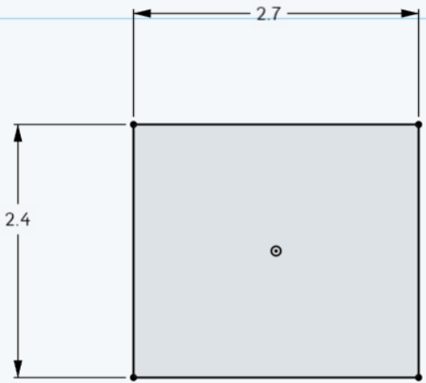

1. Use the line tool  to create 3 vertical lines and one horizontal line along the midpoints of the left and right sides of the rectangle. Your drawing should look like:

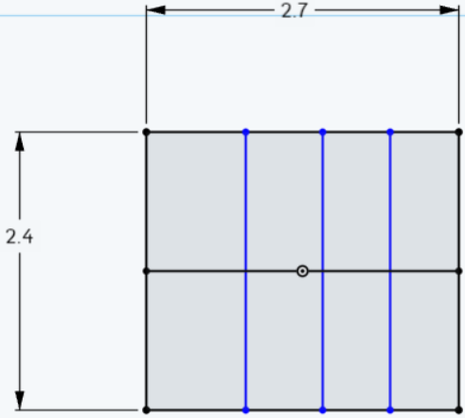

1. Dimension the drawing as follows:

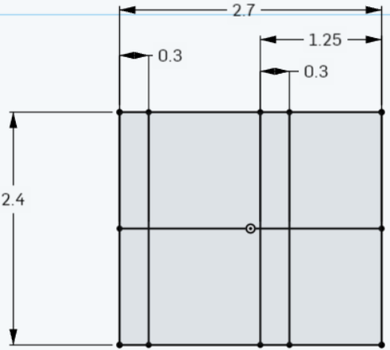

1. Draw two more lines. The first line should run from the top left corner to the second line from the left. The second line should run from just below the third line from the left to the fourth line from the left. Dimension the second line so it is 0.05” from the top line. The drawing should now look like this:

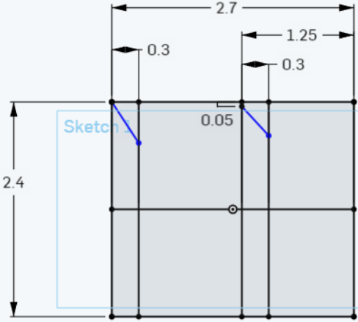

1. Use the mirror tool to mirror the two newest lines. After clicking on the mirror tool, select the middle horizontal line then the two new lines just created. Your drawing should appear as follows:

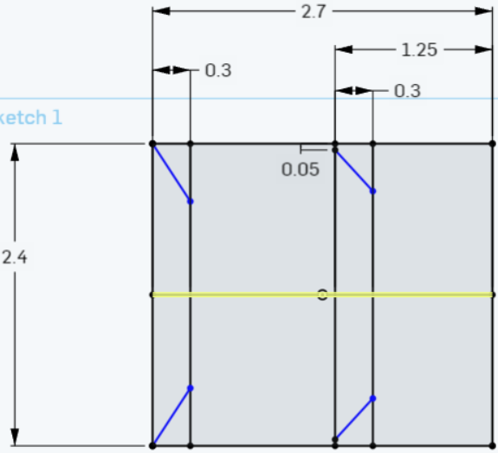

1. Use the mirror tool again to mirror three line segments across the third vertical line from the left so your drawing looks like this:

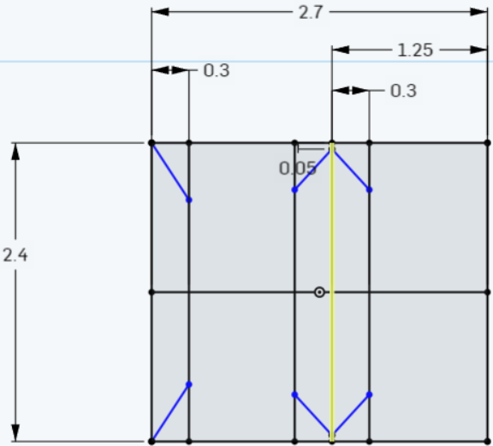

1. Dimension the new features as below:

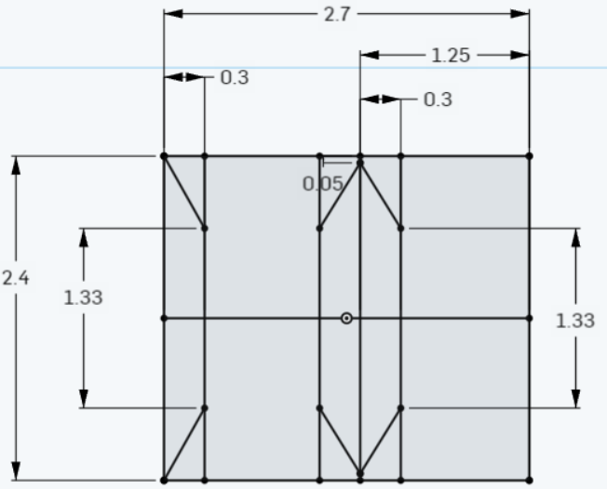

1. Select the arrow next to the 3 point arc  and select the Conic tool. Add the feature to the bottom right corner of your drawing:

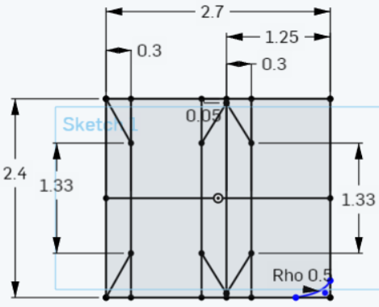

1. Drag the floating blue circle to the bottom right corner of the drawing and dimension the feature as follows:

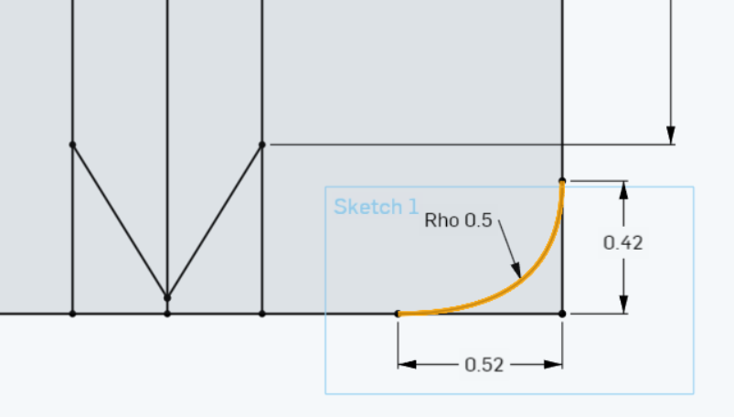

1. Mirror this feature so your drawing looks like this:

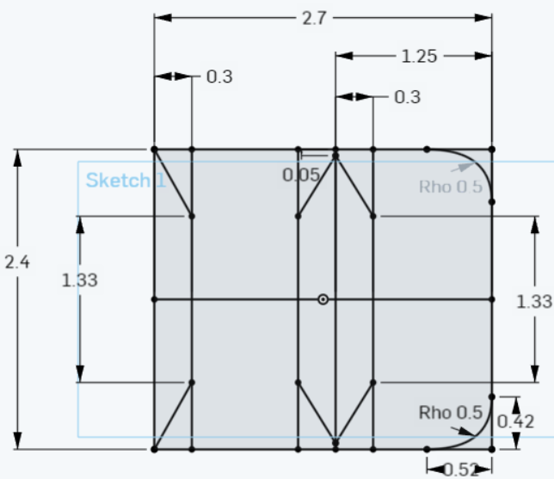

1. Use the center point circle tool to create two concentric circles above the rectangle:

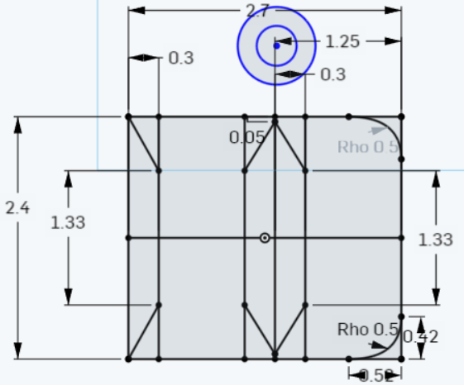

1. Select the coincident tool  and select the center of the two concentric circles and the vertical line that is approximately in the middle of the rectangle (fourth vertical line from the left). Dimension the distance of the center of the circle to the top of the rectangle to be 0.19” as well as dimension the inner circle to a diameter of 0.50” and the distance between the inner and outer circles to be 0.20”:

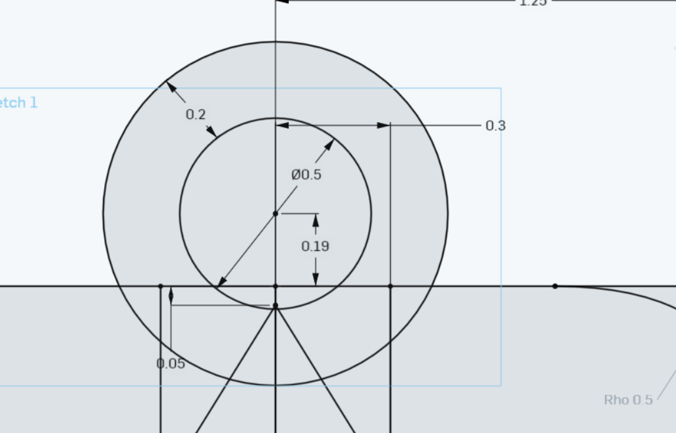

1. Select the trim feature  and selecting the unnecessary segments to create the Duke Keychain:

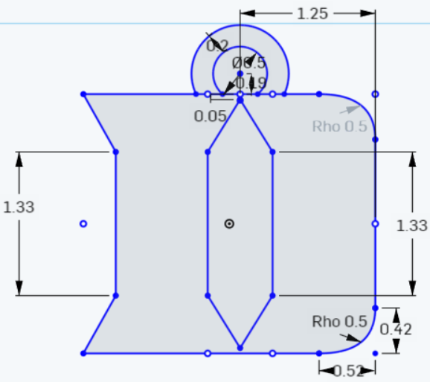

**Create a 3D Feature**

1. Use the extrude tool and extrude only the D in the drawing with the settings:

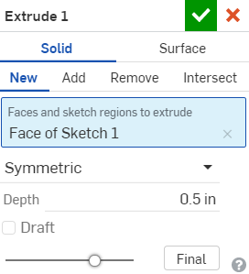

Note that you are using **Symmetric**

1. Next, extrude the half ring with the following settings:

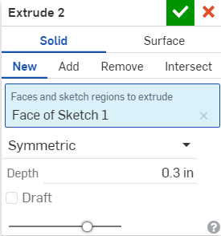

You may have to unhide Sketch 1 to be able to select the half ring

1. Your drawing should now look like this:

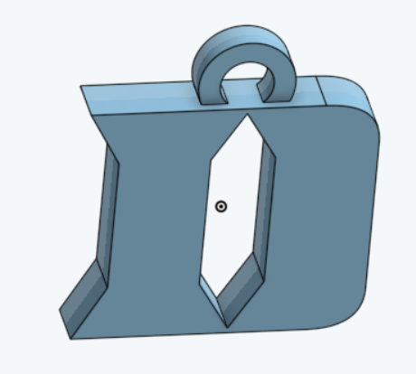

1. Select the fillet tool  and select the front and back faces of the half ring with the following settings:

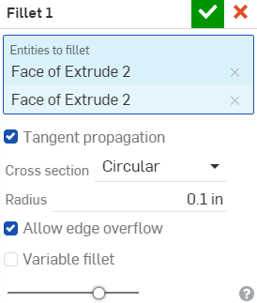 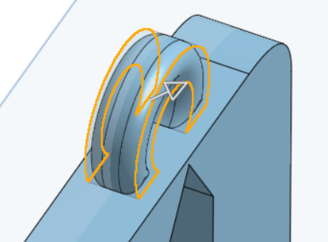

1. Your keychain should look like:



1. Finally, add any custom features such as devil horns or engrave your name to get the final points for 100%!